12th September 2024

Dear Colleague

Annual General Meeting
Towner Art Gallery
Wednesday 9th October 2024 at 6pm

Notice is hereby given that the Annual General Meeting of Your Eastbourne BID Limited will be held on Wednesday 9th October at 6.00pm, when it is hoped you will be able to attend.

The papers for the meeting, including the minutes of the AGM on 30th August 2023 and the accounts for 2022/23 are available via the BID’s website on the Home Page at http://www.youreastbournebid.com.

Please follow the link on our website to register your place so that you can be afforded voting rights at the AGM. We ask that you sign up to attend by Sunday 6th October 2024. You can also sign up here: https://forms.office.com/e/MZyrc7bV92

Details of proxy voting are also available on the BID website. There are no passwords required to access this part of the site.

AGENDA
- To read the notice convening the Meeting.
- Apologies for absence.
- Approval of the Minutes of the AGM on August 30th 2023
- To receive, consider and adopt the Annual Accounts, Balance Sheet & Auditors’ Report for the year to 31st August 2023.
- To re-elect Directors to the Board of Your Eastbourne BID
- To receive new nominations for Directors, to be considered by the Board at the first Board meeting post AGM
- To receive, consider and approve the Chair’s Report for 2022 / 2023
- Chair’s Address for 2023 / 2024.
- Any other business which the Chair may admit

Drinks and canapés will be served and there will be opportunities for networking and discussion with the BID’s Board of Directors and staff, along with our members.

Please bring your personal copy of the relevant AGM papers with you.

The Board of Directors, BID Team and I look forward to seeing you on Wednesday 9th October 2024.

Yours sincerely
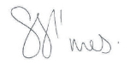 | 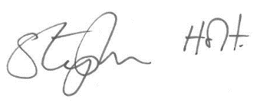
Shoes Simes Stephen Holt
Chair Chief Executive

